**PROJECT EXECUTION STEPS**

**User:** Registers in the application by giving the details asked in the form.

**Login:** Logs in into the page by providing the credentials user registered with. **Upload:** Uploads the data into the model.

**System:** Preprocess the dataset. System passes the data into model and Gives the result

**HOME PAGE:**



Fig 14: The Home page of the Digital Signature Recognition System

**REGISTER:**

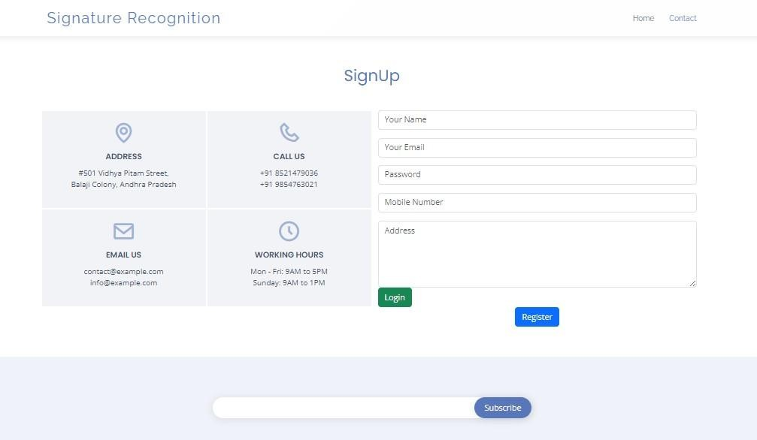

Fig 15: Registration page for the new users

**LOGIN:**



Fig 16: The login page for the existed users

**UPLOAD:**



Fig 17: The upload page to give the digital signatures as input

**OUTPUT**

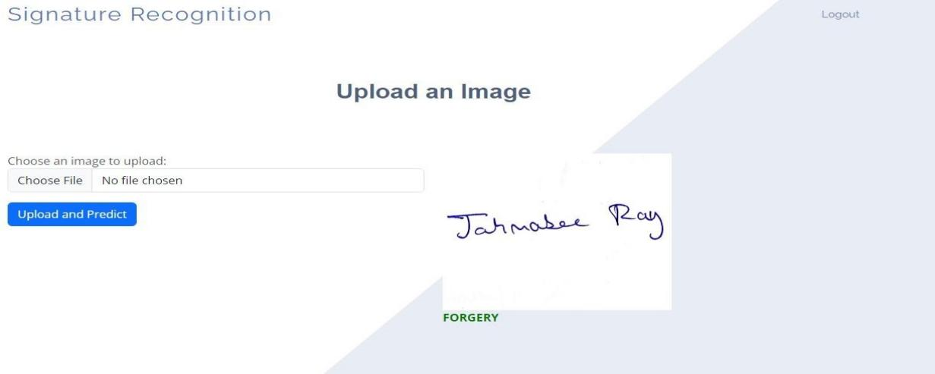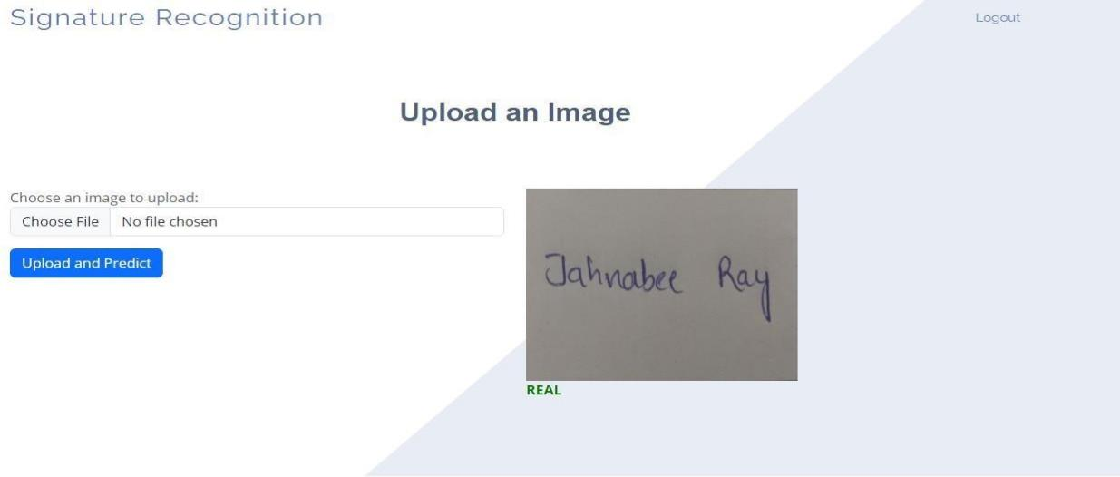

Fig 18 & 19: The classification of the signatures (Forgery or Real)